**Smart Parking System**

**\*\*Components Needed:\*\***

**1. Ultrasonic sensors (for detecting car presence)**

**2. Arduino board (to control the system)**

**3. LED lights (to indicate parking spot status)**

**4. Wi-Fi module (to enable IoT connectivity)**

**5. Tinkercad for simulation**

**\*\*Steps to Implement:\*\***

**1. **Sensor Setup:\*\*** Connect ultrasonic sensors to the Arduino board to detect car presence in parking spots.

**2. **LED Indicators:\*\*** Attach LED lights to each parking spot. Green indicates an available spot, while red indicates an occupied spot.

**3. **Arduino Programming:\*\*** Write code to read sensor data and control the LEDs accordingly. Use conditional statements to change LED colors based on sensor inputs.

**4. **Wi-Fi Integration:\*\*** Add a Wi-Fi module (e.g., ESP8266) to the Arduino to enable IoT connectivity.

**5. **IoT Platform:\*\*** Create an account on an IoT platform like ThingSpeak or Adafruit IO. Configure the Wi-Fi module to send parking spot status (available or occupied) to the cloud.

**6. **User Interface:\*\*** Design a simple web interface or mobile app (you can use Tinkercad's simulation capabilities) to display parking spot status in real-time.

**7. **IoT Integration:\*\*** Connect the IoT platform to your web/mobile interface to fetch and display parking spot data.

**8. **Testing:\*\*** Simulate car arrivals and departures in Tinkercad to see how the system reacts and updates the status.

**9. **Documentation:\*\*** Prepare documentation explaining the project, components used, code, and how it works.

**10. **Presentation:\*\*** Create a presentation to showcase your project's features, benefits, and the technology used.

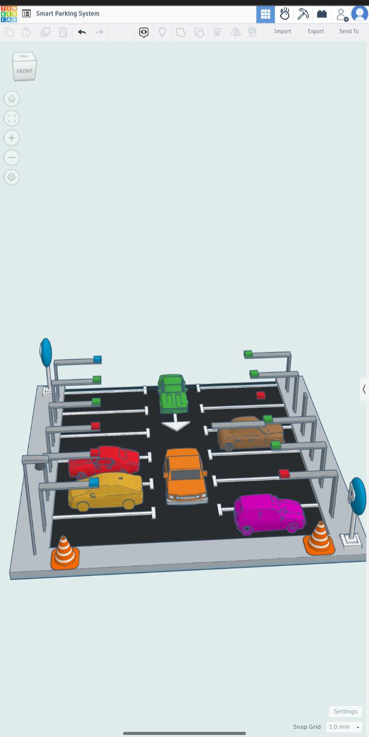

Fig: Smart Parking System Design

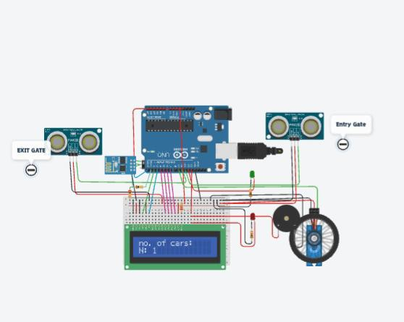

Fig: Smart Parking System Sensors with circuit